Write a C++ program to calculate distance between two points. The values of coordinates should be input by user.

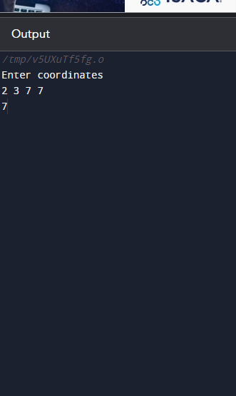#include <iostream>

using namespace std;

int main() {

int x, y, X, Y;

double d;

cout<< "Enter coordinates\n";

cin>> x>>y>>X>>Y;

d=((x-X)^2 + (y-Y)^2);

cout<< d;

return 0;

}

Write a code in C++ to take length from user in centimeter and convert it into meter and kilometer.

#include <iostream>

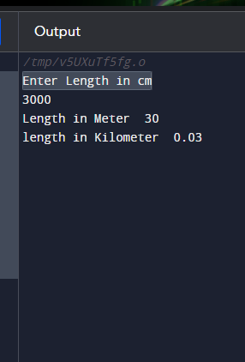using namespace std;

int main() {

float cm, m, km;

cout<<"Enter Length in cm\n";

cin>> cm ;

m=cm/100;

km= m/1000;

cout<<"Length in Meter"<<" "<< m<<endl;

cout<<"length in Kilometer"<<" "<<km;

return 0;

}

Write a code in C++ that takes values of a and b from the user and displays result of polynomial

#include <iostream>

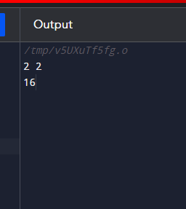using namespace std;

int main() {

int a, b, c;

cin >> a>>b;

c= (a\*a+2\*a\*b+b\*b);

cout<< c;

return 0;

}

Write a program in C++ to convert temperature in Fahrenheit to Celsius.

#include <iostream>

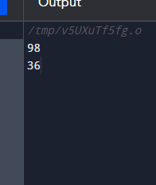using namespace std;

int main() {

int C, F ;

cin >> F;

C=(F-32)\*5/9;

cout<< C;

return 0;

}